# Lab: Model Forms

## Create a new Project

Create a **new project** and an **application**.

## Create a Book Model

Each book should have the following fields:

* **title** – **CharField** with max-length of 20
* **pages** – **IntegerField** with default value of 0
* **description** – **CharField** with max length of 100 and empty string as a default value
* **author** – **CharField** with max length of 20

## Create a Model Form

Add the following styling to the form:

* **title** – **TextInput** with class form-control
* **pages** – **NumberInput** with class form-control
* **author** – **TextInput** with class form-control
* **description** – **Textarea** with class form-control

## Create the Views

Create an **edit** and **create view** (use the provided templates)

The **edit view** should render the following form with the current data of the book

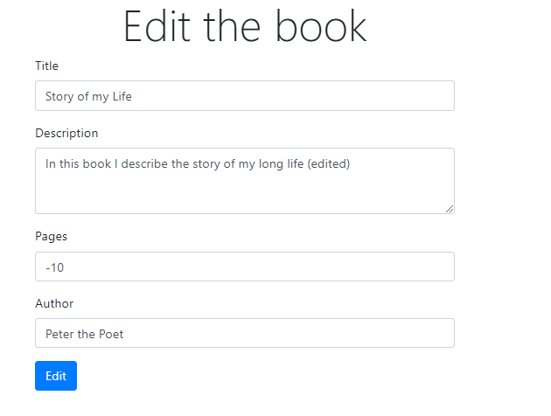

The create view should render the **create form**

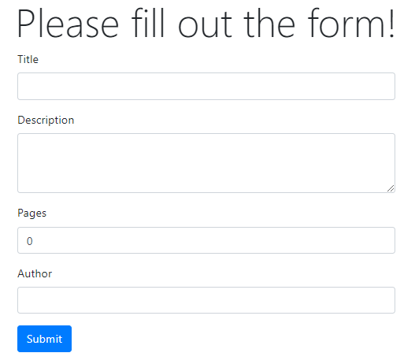

## Validate the Form

**Validate** the **pages count** of the form, they cannot be **less than** or **equal** to **zero**